# **Introduction to JavaScript**

**📌 What is JavaScript?**

JavaScript is a lightweight, interpreted, high-level programming language primarily used for **web development** to make websites interactive.

**✅ Key Features:**

* Client-side scripting (runs in browser)
* Dynamically typed
* Event-driven
* Supports OOP and functional programming

**🕒 Why It Came:**

To add interactivity to websites—HTML was static, and JavaScript allowed dynamic behavior like form validation, animations, etc.

**🌐 Example Use Case:**

<button onclick="alert('Hello!')">Click Me</button>

**🧠 Who Invented JavaScript?**

**Brendan Eich** invented JavaScript in **1995** while working at **Netscape Communications**.

**📆 When Was JavaScript Invented?**

* ✅ **Year**: 1995
* 🏢 **Company**: Netscape
* ⏱️ **Time Taken**: Just **10 days** to build the first working version
* 👶 First appeared in **Netscape Navigator 2.0** browser

**🤔 Why Is It Called *JavaScript*?**

Despite the name, **JavaScript has nothing to do with Java**. Here's what happened:

* 🧪 The original name was **Mocha**
* Renamed to **LiveScript** during early browser testing
* Later changed to **JavaScript** as a **marketing strategy**

**📈 Why the Name Change?**

At the time, **Java** (by Sun Microsystems) was **very popular** and considered the future of programming. So, Netscape:

Renamed **LiveScript** to **JavaScript** to ride the wave of Java's hype and attract developers—even though the languages are unrelated.

**🔢 2. ECMAScript Versions (ES5, ES6, ES7…ES2024)**

**📘 ECMAScript (ES):**

It’s the standard that defines how JavaScript should work. Each version introduces improvements.

**🚀 Key Versions & Differences:**

| **Version** | **Features Introduced** |
| --- | --- |
| ES5 (2009) | Strict mode, JSON support |
| ES6 (2015) | let, const, arrow functions, classes, modules, template literals, destructuring |
| ES7-13 | Async/await, optional chaining, nullish coalescing, private class fields, top-level await |

**🔍 ES6 Example:**

const name = 'Alice';

const greet = () => `Hello, ${name}`;

console.log(greet());

**🧠 Is JavaScript Compiled or Interpreted?**

✅ Traditionally:

JavaScript was considered an interpreted language — meaning it was read and executed line-by-line by the browser’s engine (like V8 in Chrome).

✅ Modern JavaScript (Today):

JavaScript is now both interpreted and compiled — it uses a technique called Just-In-Time (JIT) Compilation.

🔥 JIT Compilation: The browser compiles JavaScript just before execution, optimizing it while still allowing dynamic behavior.

**🚀 How JIT Works (High-Level Flow):**

JavaScript source code is parsed by the engine.

It's compiled into an intermediate format (bytecode).

Frequently used parts are optimized and compiled into machine code.

Unused or slow parts may be de-optimized later if needed.

So it's not pre-compiled like Java (with .class files), but also not interpreted purely line-by-line anymore.

🌀 How JavaScript Supports Dynamic Typing

🔹 **JavaScript is Dynamically Typed:**

This means variables don’t have fixed types. The type is determined at runtime, and you can change it.

let x = 10; // x is a number

x = "hello"; // now x is a string!

x = true; // now x is a boolean

🧬 Behind the scenes:

Variables are containers that can hold any data type.

JavaScript engines use a structure called a tagged value to keep track of the type.

Every value has metadata describing its type at runtime.

🤖 Example (in the engine):

let value = 42;

// internally might look like:

{ type: "number", data: 42 }

And later:

value = "forty-two";

// engine updates it to:

{ type: "string", data: "forty-two" }

⚖️ Comparison with Java (Statically Typed)

| **Feature** | **JavaScript** | **Java** |
| --- | --- | --- |
| Typing | Dynamically typed | Statically typed |
| Type checking | At runtime | At compile-time |
| Variable type change | Allowed | Not allowed |
| Compilation | JIT compiled | Compiled (to bytecode) |
| Type declaration | Optional (let, const) | Mandatory (int, String, etc.) |

🎯 Real-World Benefit of Dynamic Typing in JavaScript

Quick prototyping: No need to declare types—great for building fast.

Flexible code: A function can handle multiple types.

function log(value) {

console.log("Value is:", value);

}

log(10); // number

log("hi"); // string

log([1, 2, 3]); // array

✅ Summary

| **Question** | **Answer** |
| --- | --- |
| **Is JavaScript compiled?** | Yes, via **JIT compilation** (interpreted + compiled) |
| **How is dynamic typing supported?** | Variables are checked and resolved at **runtime**, with flexible underlying memory structures |
| **Benefit?** | Rapid development, flexibility, but requires good discipline to avoid type-related bugs |

**📦 3. JavaScript Implementation**

**🧮 Variables:**

let age = 25;

const PI = 3.14;

var city = 'New York';

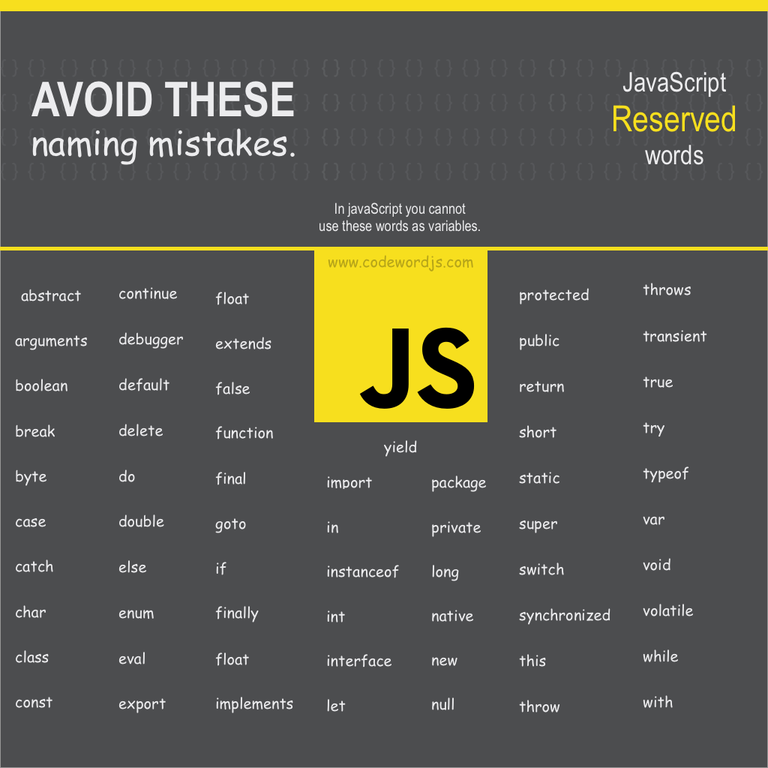

**🧬 Data Types:**

* Primitive: String, Number, Boolean, Null, Undefined, Symbol, BigInt
* Reference: Object, Array, Function

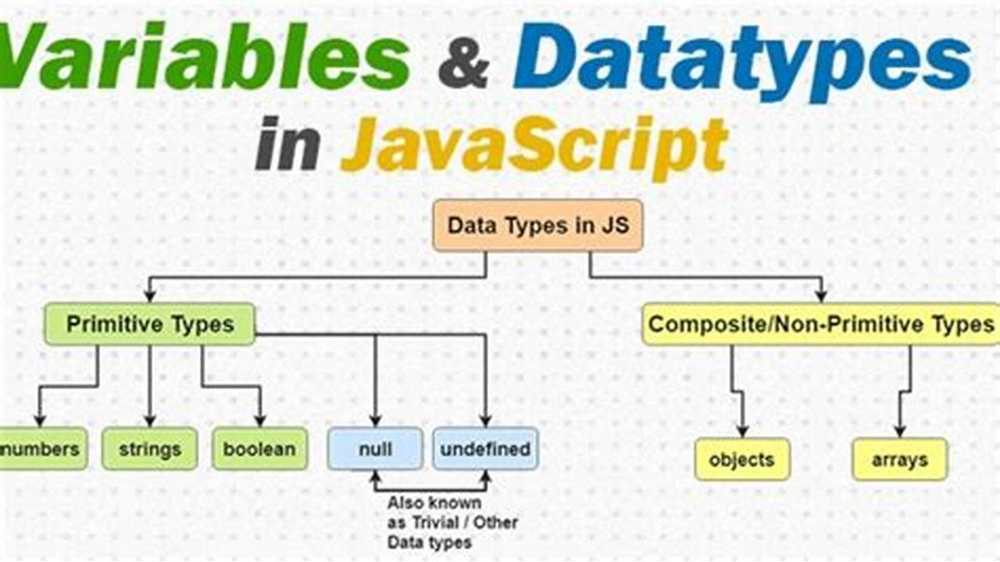

**🔗 Operators:**

let x = 10;

x += 5; // Arithmetic

x > 5; // Comparison

x && true; // Logical  
  
Same as Java

🔍 2. Key Differences

🔄 Equality Operators (== vs ===)

| **Java** | **JavaScript** |
| --- | --- |
| == compares values, **type-safe** | == does **type coercion** (loose equality) |
| .equals() checks object content | === checks both value and **type** (strict) |

// Java

System.out.println(5 == 5); // true

System.out.println("5" == 5); // false

// JavaScript

console.log(5 == '5'); // true (type coercion)

console.log(5 === '5'); // false (strict comparison)

**➕ String + Number Behavior**

| **Java** | **JavaScript** |
| --- | --- |
| + works for numbers or strings | If a string is involved, JS converts others to strings |

// Java

System.out.println(5 + "5"); // Output: 55 (int + String = String)

// JavaScript

console.log(5 + '5'); // Output: '55' (number + string = string)

**🔎 typeof vs instanceof**

| **Java** | **JavaScript** |
| --- | --- |
| instanceof for object types | typeof checks primitive type, instanceof for objects |

String s = "Hello";

System.out.println(s instanceof String); // true

let s = "Hello";

console.log(typeof s); // \"string\"

console.log(s instanceof String); // false (primitive)

**💻 Type Sensitivity**

* Java is **strongly and statically typed**
* JavaScript is **loosely and dynamically typed**

This affects how operators work, especially comparison and assignment.

**❓ Conditional Statements:**

if (age > 18) {

console.log('Adult');

} else {

console.log('Minor');

}

**🔁 Switch Case:**

A switch statement allows you to execute different code blocks based on the value of an expression. It’s an alternative to writing many if-else-if conditions

**✅ Syntax (JavaScript):**

switch (expression) {

case value1:

// code block

break;

case value2:

// code block

break;

default:

// code block

}

**🔹 Rules in JavaScript:**

* expression can be **any type** (string, number, boolean, etc.).
* Uses **strict comparison (===)**.
* break is **optional** (omit it to allow fall-through).
* default is **optional**.

let color = 'red';

switch (color) {

case 'red': console.log('Stop'); break;

case 'green': console.log('Go'); break;

default: console.log('Unknown');

}

🔍 Key Differences in Switch

| **Feature** | **Java** | **JavaScript** |
| --- | --- | --- |
| Valid data types | int, char, enum, String | Any type (number, string, boolean) |
| Comparison type | == or equals() | Strict (===) |
| Fall-through by default | ✅ Yes | ✅ Yes |
| Requires break | ✅ Yes | ✅ Yes |
| Case values | Must be constant | Can be expressions (but usually constants) |
| Arrow functions / lambdas | ✅ Java 14+ | ❌ Not directly |
| Return from switch | ✅ Java 14+ switch expression | ✅ Possible |

**🔍 Key Differences in Conditional Statements**

| **Feature** | **Java** | **JavaScript** |
| --- | --- | --- |
| 🔠 Type-safety | ✅ Strongly typed (must be boolean) | ❌ Loosely typed (any truthy/Falsey value allowed) |
| 🔄 Type coercion | ❌ No coercion | ✅ Automatically coerces values to boolean |
| 🧪 Conditions | Must evaluate strictly to boolean | Any value can be used (truthy/falsy) |
| 🧱 Block requirement | Optional for one-liners, but recommended | Same, but more flexible |
| 🧩 Short-circuiting | Supported | Supported |

**📌 Truthy and Falsey Values (JavaScript only)**

JavaScript allows **non-boolean values** in conditions:

**✅ Truthy examples:**

* "hello", 42, [], {}, true

**❌ Falsy examples:**

* 0, "", null, undefined, NaN, false

// Javascript

if ("") {

console.log("This won't run"); // falsy

}

if ("hello") {

console.log("This will run"); // truthy

}  
  
In **Java**, the condition must be a strict boolean:

String s = "";

if (s) { // ❌ Compile-time error

System.out.println("This won't compile");

}

**Example of Differences**

🔸 Java (Error if condition not boolean)

int value = 10;

if (value) { // ❌ Error: cannot convert int to boolean

System.out.println("Not allowed in Java");

}

🔸 JavaScript (Works due to type coercion)

let value = 10;

if (value) { // ✅ Works: 10 is truthy

console.log("Allowed in JavaScript");

}

**📄 4. JSON (JavaScript Object Notation)**

**🧩 What is JSON?**

**JSON stands for JavaScript Object Notation.  
It’s a lightweight data-interchange format that's:**

* **Easy for humans to read and write**
* **Easy for machines to parse and generate**

**✅ JSON is a string format that represents structured data (like objects, arrays, numbers, strings).**

**🧠 Why JSON?**

* **Standard format for APIs and data transfer**
* **Language-independent (but inspired by JavaScript syntax)**
* **Replaces XML in many modern systems**
* **Used for storing, sending, and receiving data between client and server**

**🔹 JSON Structure Example**

**{**

**"name": "Alice",**

**"age": 25,**

**"isStudent": false,**

**"skills": ["JavaScript", "HTML", "CSS"],**

**"address": {**

**"city": "New York",**

**"zip": "10001"**

**}**

**}**

**🔸 JSON in JavaScript**

**✅ Converting a JS object to JSON**

**const user = {**

**name: "Alice",**

**age: 25,**

**isStudent: false**

**};**

**const jsonString = JSON.stringify(user);**

**console.log(jsonString);**

**// Output: '{"name":"Alice","age":25,"isStudent":false}'**

**✅ Converting JSON to JS object**

**const jsonData = '{"name":"Alice","age":25,"isStudent":false}';**

**const userObject = JSON.parse(jsonData);**

**console.log(userObject.name); // "Alice"**

**🔐 JSON Syntax Rules**

| **Rule** | **Example** |
| --- | --- |
| **Data is in key-value pairs** | **"name": "Alice"** |
| **Keys are always strings** | **"age": 25** |
| **Values can be** | **String, Number, Boolean, Array, Object, null** |
| **Strings must use double quotes** | **' not allowed in JSON strings** |
| **No functions, comments, or variables allowed** |  |

**🧑‍💻 Real-world Examples**

**🔹 Sending data in an API call**

**fetch("/login", {**

**method: "POST",**

**headers: { "Content-Type": "application/json" },**

**body: JSON.stringify({ username: "admin", password: "1234" })**

**});**

**🔹 Receiving and using data from a REST API**

**fetch("/profile")**

**.then(response => response.json())**

**.then(data => {**

**console.log(data.name); // Access value from parsed JSON**

**});**

**🔹 Storing structured data in localStorage**

**const cart = [{ id: 101, qty: 2 }];**

**localStorage.setItem("cart", JSON.stringify(cart));**

**const savedCart = JSON.parse(localStorage.getItem("cart"));**

**🆚 JSON vs JavaScript Objects**

| **Feature** | **JavaScript Object** | **JSON** |
| --- | --- | --- |
| **Can have functions** | **✅ Yes** | **❌ No** |
| **Syntax flexibility** | **✅ More relaxed (single quotes, trailing commas)** | **❌ Strict (double quotes, no trailing commas)** |
| **Used for** | **Working with data in-memory** | **Sending/storing structured data** |
| **Supports parsing/stringify** | **✅ via JSON methods** | **✅ via JSON.parse / stringify** |

**📌 Summary**

| **Concept** | **JSON in JavaScript** |
| --- | --- |
| **Full form** | **JavaScript Object Notation** |
| **Purpose** | **Exchange/store structured data** |
| **Key Methods** | **JSON.stringify(), JSON.parse()** |
| **Used in** | **APIs, localStorage, config files** |
| **Strict syntax** | **✅ Must follow JSON format** |

**🔧 5. Functions in JavaScript**

**✅ What is a Function?**

**A function is a block of reusable code designed to perform a particular task.**

**🔹 Basic Syntax:**

**function greet(name) {**

**return "Hello, " + name + "!";**

**}**

**console.log(greet("Alice")); // "Hello, Alice!"**

**🧰 Types of Functions in JavaScript**

**1. Function Declaration**

**function add(a, b) {**

**return a + b;**

**}**

**2. Function Expression**

**const multiply = function(a, b) {**

**return a * b;**

**};**

**3. Arrow Function (ES6+)**

**const divide = (a, b) => a / b;**

**4. Anonymous Functions**

**Functions without a name, often used in callbacks:**

**setTimeout(function() {**

**console.log("Time's up!");**

**}, 1000);**

**5. Immediately Invoked Function Expressions (IIFE)**

**(function() {**

**console.log("IIFE runs immediately!");**

**})();**

**🪄 Special Characteristics of JS Functions**

| **Feature** | **Description** |
| --- | --- |
| **First-class citizens** | **Can be stored in variables, passed as arguments, and returned** |
| **Closures** | **Functions remember the scope where they were created** |
| **No strict return type** | **Can return any type** |
| **Variable arguments** | **Functions can be called with any number of args** |
| **arguments object** | **Holds all passed values (non-arrow functions)** |

**✅ Real-world Examples**

**🧾 Form validation function**

**function validateEmail(email) {**

**return email.includes("@") && email.endsWith(".com");**

**}**

**📦 Utility function in eCommerce**

**const calculateDiscount = (price, percentage) => price - (price * percentage / 100);**

**🔁 Higher-order function for filtering**

**const numbers = [1, 2, 3, 4];**

**const evenNumbers = numbers.filter(num => num % 2 === 0);**

**🆚 Part 2: Functions in Java vs JavaScript – Key Differences**

| **Feature** | **Java** | **JavaScript** |
| --- | --- | --- |
| **Declaration** | **Must be inside a class** | **Can be standalone** |
| **Syntax** | **Strongly typed** | **Loosely typed** |
| **Return type** | **Must be declared** | **Optional (any type returned)** |
| **Function Overloading** | **✅ Yes (based on parameters)** | **❌ No (can use logic to simulate)** |
| **Default Parameters** | **❌ (simulate with overloading)** | **✅ Yes (natively supported)** |
| **Variable Arguments** | **✅ Yes (varargs ...args)** | **✅ Yes (rest parameters ...args)** |
| **Anonymous Functions** | **✅ Lambda (Java 8+)** | **✅ Closures, arrow functions** |
| **First-Class Functions** | **❌ Not supported** | **✅ Fully supported** |
| **Must be inside class** | **✅ Yes** | **❌ No (can be anywhere)** |

**🧑‍💻 Example Comparison**

**✅ Java Function**

**public class Main {**

**public static String greet(String name) {**

**return "Hello, " + name + "!";**

**}**

**public static void main(String[] args) {**

**System.out.println(greet("Alice"));**

**}**

**}**

**✅ JavaScript Equivalent**

**function greet(name) {**

**return "Hello, " + name + "!";**

**}**

**console.log(greet("Alice"));**

**🧩 6. Arrays & Strings**

**🔹 Arrays:**

let fruits = ['apple', 'banana', 'cherry'];

fruits.push('orange'); // Add

console.log(fruits[1]); // Access

**📦 1. Basic Concept**

| **Feature** | **Java** | **JavaScript** |
| --- | --- | --- |
| Language Type | **Statically typed** | **Dynamically typed** |
| Array Type | Fixed type and size | Can hold mixed types, dynamic size |
| Declaration | Explicit with type | Implicit and flexible |

📐 **2. Array Declaration & Initialization**

🔹 Java:

int[] numbers = new int[3]; // Empty array of size 3

String[] fruits = {"apple", "banana", "mango"};

* Type and size are fixed at compile time.
* Cannot store multiple data types in one array.

🔹 JavaScript:

let numbers = [1, 2, 3];

let mixed = [42, "apple", true];

* Arrays can grow/shrink dynamically.
* Can store multiple data types in the same array.

**🔄 3. Accessing Elements**

**Java:**

System.out.println(fruits[1]); // banana

**JavaScript:**

console.log(fruits[1]); // banana

✅ Similar syntax for indexing.

**🔁 4. Looping Through Arrays**

**Java:**

for (int i = 0; i < fruits.length; i++) {

System.out.println(fruits[i]);

}

**JavaScript:**

for (let i = 0; i < fruits.length; i++) {

console.log(fruits[i]);

}

➡️ JavaScript also supports other methods like forEach, map, filter, etc.

**🔧 5. Built-in Methods**

**Java (Using Arrays class):**

import java.util.Arrays;

Arrays.sort(fruits);

**JavaScript (Array methods):**

fruits.sort();

fruits.push("orange");

let result = fruits.join(", ");

* JavaScript has **richer array methods** built into the array itself.
* Java uses utility classes like Arrays or Collections.

**🧮 6. Dynamic Behavior**

**Java:**

int[] arr = new int[2];

arr[2] = 5; // ❌ Runtime Error: ArrayIndexOutOfBoundsException

**JavaScript:**

let arr = [10, 20];

arr[5] = 50; // ✅ Works, empty slots are created

console.log(arr); // [10, 20, <3 empty items>, 50]

JavaScript arrays are **sparse** and **dynamic**, Java arrays are **dense** and **fixed-size**.

**🧬 7. Type of Array**

**Java:**

System.out.println(fruits instanceof String[]); // true

**JavaScript:**

console.log(Array.isArray(fruits)); // true

console.log(typeof fruits); // 'object'

In JavaScript, arrays are a **special kind of object**.

**🧪 8. Example Comparison**

**🔸 Java**

String[] cars = new String[3];

cars[0] = "Tesla";

cars[1] = "BMW";

cars[2] = "Audi";

**🔸 JavaScript**

let cars = ["Tesla", "BMW", "Audi"];

cars.push("Toyota"); // Add dynamically

**📚 JavaScript Array Methods (with Real-World Use Cases)**

**1. push() – Add element to end**

let cart = ["apple", "banana"];

cart.push("mango");

console.log(cart); // ["apple", "banana", "mango"]

🛒 **Use Case**: Adding an item to a shopping cart.

**2. pop() – Remove last element**

let cart = ["apple", "banana", "mango"];

let lastItem = cart.pop();

console.log(lastItem); // "mango"

🧹 **Use Case**: Removing the most recently added item.

**3. shift() – Remove first element**

let queue = ["user1", "user2", "user3"];

queue.shift();

console.log(queue); // ["user2", "user3"]

👥 **Use Case**: Handling queue operations like customer service lines.

**4. unshift() – Add element to start**

let queue = ["user2", "user3"];

queue.unshift("user1");

console.log(queue); // ["user1", "user2", "user3"]

⏳ **Use Case**: Prepending high-priority tasks to a queue.

**5. map() – Transform each item**

let prices = [100, 200, 300];

let taxed = prices.map(price => price * 1.18);

console.log(taxed); // [118, 236, 354]

🧾 **Use Case**: Calculating tax for each product in a cart.

**6. filter() – Keep items that match a condition**

let products = ["TV", "Mobile", "AC", "Laptop"];

let filtered = products.filter(item => item.length > 5);

console.log(filtered); // ["Mobile", "Laptop"]

🧼 **Use Case**: Filtering out short product names or irrelevant items.

**7. reduce() – Combine all items into one value**

let bills = [100, 200, 50];

let total = bills.reduce((sum, curr) => sum + curr, 0);

console.log(total); // 350

💰 **Use Case**: Calculating total order amount.

**8. find() – Find the first matching item**

let users = [{id: 1}, {id: 2}, {id: 3}];

let user = users.find(u => u.id === 2);

console.log(user); // {id: 2}

🔍 **Use Case**: Searching for a user profile by ID.

**9. includes() – Check if value exists**

let colors = ["red", "green", "blue"];

console.log(colors.includes("green")); // true

🎨 **Use Case**: Validating selected options.

**10. some() – At least one match?**

let ages = [12, 18, 25];

let hasAdult = ages.some(age => age >= 18);

console.log(hasAdult); // true

✅ **Use Case**: Checking if any user is eligible to vote or sign up.

**11. every() – All items match?**

let scores = [80, 90, 100];

let allPassed = scores.every(score => score >= 50);

console.log(allPassed); // true

🎓 **Use Case**: Confirming all students passed the test.

**12. sort() – Sort elements (default: strings)**

let nums = [10, 5, 20];

nums.sort((a, b) => a - b); // Ascending

console.log(nums); // [5, 10, 20]

📊 **Use Case**: Sorting prices, ratings, or scores.

**13. reverse() – Reverse the array**

let list = [1, 2, 3];

list.reverse();

console.log(list); // [3, 2, 1]

🔁 **Use Case**: Showing most recent activity first.

**14. slice() – Extract portion (non-destructive)**

let names = ["Amit", "Raj", "Sara", "John"];

let shortList = names.slice(1, 3);

console.log(shortList); // ["Raj", "Sara"]

📋 **Use Case**: Pagination or previewing data.

**15. splice() – Add/Remove items (destructive)**

let team = ["A", "B", "C"];

team.splice(1, 1, "X", "Y");

console.log(team); // ["A", "X", "Y", "C"]

🔧 **Use Case**: Editing or updating a list of tasks or players.

**🎁 Bonus: Combine map, filter, reduce**

let items = [ { price: 100 }, { price: 200 }, { price: 300 } ];

let totalAfterDiscount = items

.filter(item => item.price > 100)

.map(item => item.price * 0.9)

.reduce((sum, curr) => sum + curr, 0);

console.log(totalAfterDiscount); // 450

🛍️ **Use Case**: Apply discount on expensive items and get the total.

🧠 Summary Table

| **Method** | **Purpose** | **Returns** | **Destructive** |
| --- | --- | --- | --- |
| push() | Add to end | New length | ✅ Yes |
| pop() | Remove from end | Removed item | ✅ Yes |
| shift() | Remove from start | Removed item | ✅ Yes |
| unshift() | Add to start | New length | ✅ Yes |
| map() | Transform items | New array | ❌ No |
| filter() | Filter items | New array | ❌ No |
| reduce() | Reduce to single value | One value | ❌ No |
| find() | Find one item | Item / undefined | ❌ No |
| includes() | Check if exists | Boolean | ❌ No |
| sort() | Sort items | Sorted array | ✅ Yes |
| reverse() | Reverse order | Reversed array | ✅ Yes |

**🔹 String:**

In both JavaScript and Java, strings are immutable, meaning once created, their contents cannot be changed (any operation that modifies a string returns a new one).

**🟨 Strings in JavaScript**

**🔹 Declaring Strings:**

let str1 = "Hello";

let str2 = 'World';

let str3 = `Backtick String`; // Template Literal

✅ Real-world: Storing user input, form labels, messages, API keys.

**🔹 String Properties:**

let name = "Alice";

console.log(name.length); // 5

**🔹 Common Methods (with Examples)**

**1. toUpperCase() / toLowerCase()**

let msg = "hello";

console.log(msg.toUpperCase()); // "HELLO"

📢 **Use Case**: Normalizing case for comparisons or UI.

**2. indexOf() / lastIndexOf()**

let text = "banana";

console.log(text.indexOf("a")); // 1

console.log(text.lastIndexOf("a")); // 5

🔍 **Use Case**: Searching keywords in comments or input.

**3. slice() / substring()**

let data = "Invoice_2025";

console.log(data.slice(8)); // "2025"

🧾 **Use Case**: Extracting invoice number or date.

**4. replace() / replaceAll()**

let str = "I love Java. Java is fun.";

console.log(str.replace("Java", "JavaScript"));

// "I love JavaScript. Java is fun."

🛠️ **Use Case**: Replacing banned words or dynamic content.

**5. trim() / trimStart() / trimEnd()**

let name = " Alice ";

console.log(name.trim()); // "Alice"

📋 **Use Case**: Cleaning user input in forms.

**6. split() – Convert string to array**

let tags = "html,css,js";

console.log(tags.split(",")); // ["html", "css", "js"]

🧷 **Use Case**: Handling comma-separated values in forms or databases.

**7. includes() – Check substring**

let status = "pending payment";

console.log(status.includes("payment")); // true

💳 **Use Case**: Detecting user status or keywords.

**8. startsWith() / endsWith()**

let filename = "report.pdf";

console.log(filename.endsWith(".pdf")); // true

📁 **Use Case**: Validating file types or URLs.

**9. concat()**

let greeting = "Hello".concat(" ", "World!");

🪢 **Use Case**: Dynamically joining strings (though + or template literals are more common).

**10. Template Literals (``)**

let user = "Amit";

let greet = `Hello, ${user}!`;

console.log(greet); // "Hello, Amit!"

📜 **Use Case**: Building dynamic messages, emails, HTML templates.

**✅ Real-World Project Examples (JavaScript)**

**1. Welcome message on login:**

let username = "Sana";

console.log(`Welcome back, ${username}!`);

**2. Building a search URL:**

let query = "laptop bags";

let url = `https://example.com/search?q=${encodeURIComponent(query)}`;

**3. Input Validation:**

let email = "user@example.com";

if (!email.includes("@")) {

console.log("Invalid email address");

}

**☕ Java Strings vs 🟨 JavaScript Strings**

| **Feature** | **Java** | **JavaScript** |
| --- | --- | --- |
| Declaration | String str = "Hello"; | let str = "Hello"; |
| Immutable | ✅ Yes | ✅ Yes |
| String pool optimization | ✅ (String Pool) | ❌ No pool concept |
| Comparison (==) | Compares **references** | Compares **values** |
| Useful methods | .length(), .equals(), .charAt() | .length, .includes(), .slice() |
| Multiline support | "\n" with escape characters | `` (backticks) for multiline |
| Template strings | ❌ (Manual concat) | ✅ (Template literals ``) |
| StringBuilder for performance | ✅ Yes (StringBuilder) | ❌ No built-in, strings just work |

**🔍 Java String Comparison Example:**

String a = "Hello";

String b = "Hello";

System.out.println(a == b); // true (same pool reference)

System.out.println(a.equals(b)); // true (content check)

In JavaScript:

let a = "Hello";

let b = "Hello";

console.log(a === b); // true (value comparison)

**💻 7. Practical Working (Example Use Case)**

**🌐 User Login Check Example:**

const users = [

{ username: 'alice', password: '123' },

{ username: 'bob', password: '456' }

];

function login(inputUser, inputPass) {

const found = users.find(

(user) => user.username === inputUser && user.password === inputPass

);

return found ? 'Login Successful' : 'Invalid Credentials';

}

console.log(login('alice', '123')); // Output: Login Successful

**📊 JSON & Display Data:**

const data = '[{"name":"Pen","price":10},{"name":"Book","price":100}]';

const products = JSON.parse(data);

products.forEach(p => console.log(`${p.name} - ₹${p.price}`));

**🔚 Summary**

| **Concept** | **When to Use** | **Why It Came** |
| --- | --- | --- |
| JS Basics | Any web interactivity | HTML alone was static |
| ECMAScript | Modern JavaScript features | To evolve JS |
| Variables, Conditions | Core programming | Dynamic behavior |
| JSON | Data exchange | Server-client communication |
| Functions | Code reuse | DRY principle |
| Array, String | Data manipulation | Real-world logic |